Problem 1

1. i.

Xijk denotes the route a refrigerator travels from Plant Pi to Warehouse Wj to Retailer Rk

Minimize Shipping Costs = 15X111 + 16X112 + 17X113 + 20X114 + 27X123 + 23X124 + 25X125 + 29X126 + 16X211 + 17X212 + 18X213 + 21X214 + 20X223 + 16X224 + 18X225 + 22X226 + 18X311 + 19X312 + 20X313 + 23X314 + 20X323 + 16X324 + 18X325 + 14X326 + 23X334 + 21X335 + 21X336 + 15X337 + 26X423 + 22X424 + 24X425 + 28X426 + 22X434 + 20X435 + 20X436 + 14X437

X1jk <= 150

X2jk <= 450

X3jk <= 250

X4jk <= 150

Xij1 >= 100

Xij2 >= 150

Xij3 >= 100

Xij4 >= 200

Xij5 >= 200

Xij6 >= 150

Xij7 >= 100

Xijk >= 0 for all i, j, k

Optimal Solution for Shipping Routes with Minimal Cost

P1 to W1: 150 units

P2 to W1: 200 units

P2 to W2: 250 units

P3 to W2: 250 units

P4 to W3: 150 units

W1 to R1: 100 units

W1 to R2: 150 units

W1 to R3: 100 units

W2 to R4: 200 units

W2 to R5: 150 units

W2 to R6: 150 units

W3 to R5: 50 units

W3 to R7: 100 units

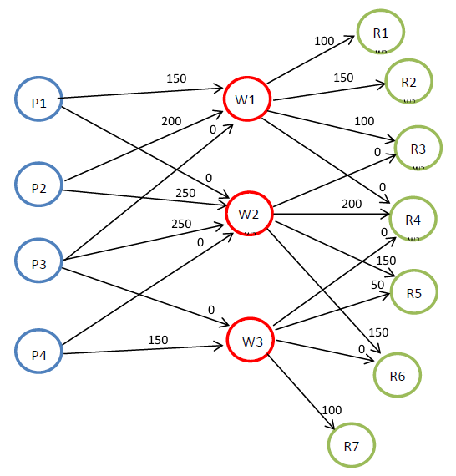

Code using Lindo7:

MIN

15 X111 + 16 X112 + 17 X113 + 20 X114 +

27 X123 + 23 X124 + 25 X125 + 29 X126 +

16 X211 + 17 X212 + 18 X213 + 21 X214 +

20 X223 + 16 X224 + 18 X225 + 22 X226 +

18 X311 + 19 X312 + 20 X313 + 23 X314 +

20 X323 + 16 X324 + 18 X325 + 14 X326 +

23 X334 + 21 X335 + 21 X336 + 15 X337 +

26 X423 + 22 X424 + 24 X425 + 28 X426 +

22 X434 + 20 X435 + 20 X436 + 14 X437

ST

X111 + X112 + X113 + X114 + X123 + X124 + X125 + X126 < 150

X211 + X212 + X213 + X214 + X223 + X224 + X225 + X226 < 450

X311 + X312 + X313 + X314 + X323 + X324 + X325 + X326 + X334 + X335 + X336 + X337 < 250

X423 + X424 + X425 + X426 + X434 + X435 + X436 + X437 < 150

X111 + X211 + X311 > 100

X112 + X212 + X312 > 150

X113 + X123 + X213 + X223 + X313 + X323 + X423 > 100

X114 + X124 + X214 + X224 + X314 + X324 + X334 + X424 + X434 > 200

X125 + X225 + X325 + X335 + X425 + X435 > 200

X126 + X226 + X326 + X336 + X426 + X436 > 150

X337 + X437 > 100

X111 > 0

X112 > 0

X113 > 0

X114 > 0

X123 > 0

X124 > 0

X125 > 0

X126 > 0

X211 > 0

X212 > 0

X213 > 0

X214 > 0

X223 > 0

X224 > 0

X225 > 0

X226 > 0

X311 > 0

X312 > 0

X313 > 0

X314 > 0

X323 > 0

X324 > 0

X325 > 0

X326 > 0

X334 > 0

X335 > 0

X336 > 0

X337 > 0

X423 > 0

X424 > 0

X425 > 0

X426 > 0

X434 > 0

X435 > 0

X436 > 0

X437 > 0

END

1. It is not feasible to close warehouse 3 and still meet the supply and demand constraints.

The simplest reason for this is that this would leave Warehouse 3 as the only warehouse to supply retailers R5, R6, R7. Combined the demand for those 3 Retailers is 450 units. However, Plants P3 and P4 can only produce 400 units, and they would be the only plants that can ship to W3.

1. Keeping W2 open at a limited capacity of 100 units would be feasible. This presents a new optimal solution:

P1 to W1: 150 units

P2 to W1: 400 units

P2 to W2: 50 units

P3 to W2: 50 units

P3 to W3: 200 units

P4 to W3: 150 units

W1 to R1: 100 units

W1 to R2: 150 units

W1 to R3: 100 units

W1 to R4: 200 units

W2 to R5: 50 units

W2 to R6: 50 units

W3 to R5: 150 units

W3 to R6: 100 units

W3 to R7: 100 units

Code same as above but with added constraint:

X123 + X124 + X125 + X126 + X223 + X224 + X225 + X226 + X323 + X324 + X325 + X326 + X423 + X424 + X425 + X426 < 100

